[](https://www.iiuc.ac.bd/)

**Project Proposal**

**Submission Date & Day**

**22 October, 2022 (Saturday)**

**Course Title: Microprocessor, Microcontrollers & Embedded System**

**Course Code: CSE-3524**

Submitted to-

**Md. Safayat Hossen**

Assistant Lecturer, Dept. of CSE, IIUC

**Cell: 01736161688,** [**safayathossen@iut-dhaka.edu**](mailto:safayathossen@iut-dhaka.edu)

**Submitted by**-

**Mostafa Shahriar Asif Sorowar Mahabub**

**Matric ID: C201014 Matric ID: C201032**

**Md. Shahin Shah Emdadul Islam**

**Matric ID: C201035 Matric ID: C201041**

**Section: A, 5th Sem., Department of CSE, IIUC**

**….**

**Proposal Project Name: Speed Test of a Moving Object**

**Motivation:** In order to detect the speed of a moving object, the responsible authority usually depend on a handheld gun that works on Radar Technology or Lidar Technology. This is a tedious process as the responsible authority has to manually check for over speeding for each vehicle.What if the moving object Speed Detection is made automatic? A simple automatic detection of speed of a vehicle is designed in Arduino moving object Speed Detector project, where you can place the system in one place and view the results instantly without any human intervention.

**Features:** This project, **Speed Test of a Moving Object** has some key features are that**-**

* Helps in capturing speed of moving object.
* No need of human involvement.
* Can display the speed moving object.

This project can also be used as traffic logger, traffic counter and few other traffic related applications.

**Limitations:** Our project, **Speed Test of a Moving Object** has some limitations are that**-**

* It can’t capture speed of all kinds of moving object, like fan.
* It has not any sound system, that tells you the speed.

**Social Impact:** As we said in Motivation point, with this project, one can place the system in one place and view the results (speed) instantly without any human intervention. We can take an example:

There are definite rules laid out by authorities about driving cars on roads. The most common rule in any country is speed limit in certain roads i.e., you will be in violation of the law if your car speed exceeds this limit. In that case, we can use this system.

**Sensors and Equipment’s:**

* Arduino UNO
* IR Sensors x 2
* 16X2 LCD Display Module
* Breadboard
* Connecting Wires
* Power Supply

**Future Scope:** In Future, we can add sound system in this project. By adding sound system, it can tell you the speed of a moving object besides showing the speed in display.

**Components (Sensor) Short Description:** We have used two digital IR Sensors, which consists of an IR Transmitter (IR LED), an IR Receiver (Photo Diode), a Comparator IC and a few supporting components. The IR Transmitter and Receiver Pair are placed side-by-side so that they form a Reflective Type IR Sensor. In this type, the IR Transmitter continuously emits Infrared radiations and if there is no object in front of the sensor, none of the Infrared radiation gets reflected back to the IR Receiver.

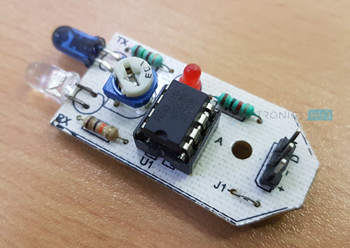

Fig.- 01: Interfacing IR Sensor with Raspberry Pi IR Sensor

But if there is an object in front of the sensor, some of the infrared radiation hits the object and gets reflected back. This reflected radiation falls on the IR Receiver, which means that the sensor has detected the object. Some IR Sensors has the option to produce both Analog and Digital Outputs but the module I have used has only Digital Output i.e. the output is HIGH when an object is detected and LOW when there is no object.

**Work Flow:** The working of the Arduino based car speed detector project is very simple. Arduino continuously reads the inputs from the IR Sensors. When a car moving in front of the setup reaches the first sensor, Arduino becomes alert and capture a time stamp the moment the car leaves the first IR Sensor. Another time stamp is recorded when the car reaches the second IR Sensor. Millis () function of Arduino used for capturing the time stamps.

For that purpose, we need to take two distance measurements in a short time apart and we have:

*distance2 - distance1 = distance speed at a given time*

**Circuit Diagram:**

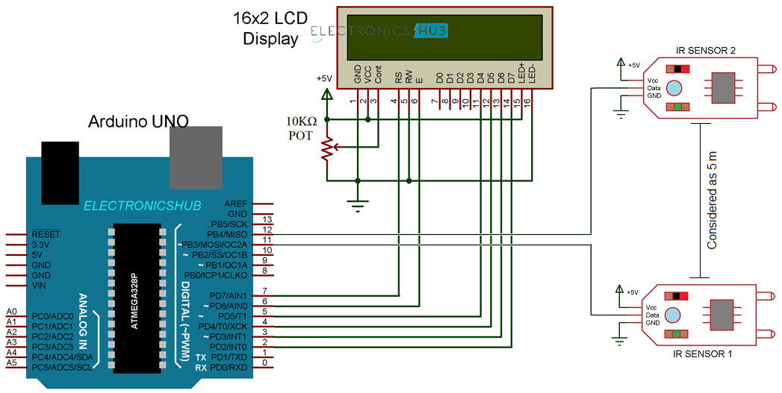

**Cost Analysis:**

* Arduino UNO x 1 - 1250 TK
* IR Sensors x 2 - 160 TK
* 16X2 LCD Display Module x 1 - 250 TK
* Breadboard x 1 - 130 TK
* Connecting Wires - 50 TK
* Power Supply x 1 - 150 TK

**In This Project, Our Total Estimated Cost Is 2000 TK To 2200 TK**

**.**

**Application:** The goal of measuring speed may vary based on the application, including the safer operation of vehicles; calculation of power as a product of speed and force; evaluation of driver travel routes based on fuel efficiency and travel time; fuel level tracking to prevent fuel theft; walking speed of diseased persons.

**Submitted by**

**Mostafa Shahriar Asif Sorowar Mahabub**

**Matric ID: C201014 Matric ID: C201032**

**Md. Shahin Shah Emdadul Islam**

**Matric ID: C201035 Matric ID: C201041**

**Section: 5AM, 5th Sem., Department of CSE, IIUC**